Swap CPE behind a CM

Version Control:

Use Case Name: |  | Swap CPE behind a CM
Use Case Owner: |  | Sumit Borade
Current Version |  | 0.6
Use Case Version History
Modified Date | Version |  | Modified By | Change Description
July 8, 2009 | 0.1 |  | Tom Schnarr | Initial Version
August 26,2009 | 0.2 |  | Sumit Borade | Removed steps not relevant to SMP
August 28,2009 | 0.3 |  | Sumit Borade | Updated after feedback from YouSee
September 30,2009 | 0.4 |  | Sumit Borade | Added Steps to Integrate with YouSee IP History Database
October 14,2009 | 0.5 |  | Sumit Borade | Added steps for Static IP Notification
October 31,2009 | 0.6 |  | Sumit Borade | Updated the description of Steps

Brief Description:
This use case describes the process by which a subscriber changes the computer (or CPE Device) they are using behind their Cable Modem

The use case is written from the perspective of the SMP provisioning solution.

Related Documents
- YouSee SMP SOW2Architecture Requirements Document
- YouSee SMP SOW2 Business Requirements Document
- Cisco BACC TC Specification
- IP Histiry Database Integration Tech Cartridge Specifications

Related Use Cases

Pre-Conditions
- Subscriber is an active broadband subscriber

Post-Conditions
- Subscriber is free to use Broadband over Cable service from the new CPE, and the old CPE is deprovisioned

Use Case

Primary Flow Diagram
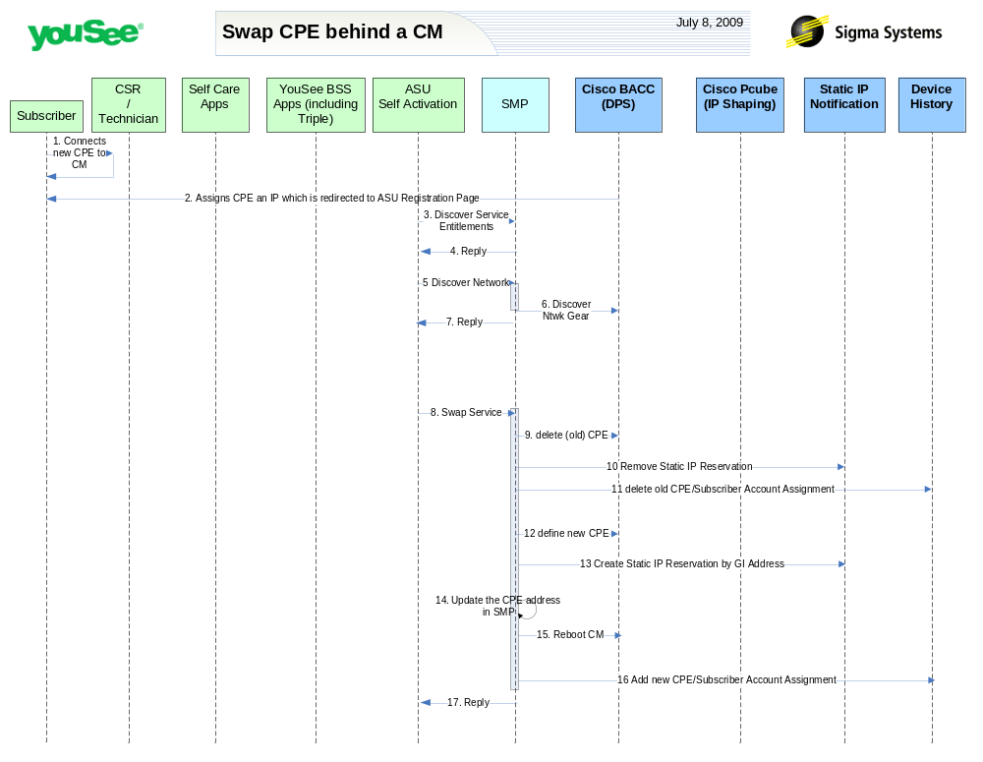

Primary Flow Detail
# | Actor: Key Action | Description | Alternate Flows/Details
 | Subscriber: Connects new CPE behind CM | Subscriber acquires a replacement CPE device and connects that device to the Ethernet port of the CM
 | BAC: Assigns CPE an IP | New CPE makes a DHCP Request which is received by BACC (CNR). Since the device is not recognized by BACC, it assigns the device an IP from the ‘unprovisioned computer’ scope.
 | ASU: calls SMP to discover the service entitlements for this subscriber | <As in Activate Broadband Use Case>
 | SMP: Replies back to ASU the information received from CISCO BACC | SMP will reply back to ASU information retrieved from CISCO BACC for CPE IP address.
 | ASU: calls SMP to discover Network Equipment serving this subscriber | <As in Activate Broadband Use Case>
 | SMP: queries BACC for network information | <As in Activate Broadband Use Case>
 | SMP: Replies back to ASU the information received from CISCO BACC | SMP will reply back to ASU information retrieved from CISCO BACC for CPE IP address.
 | ASU: requests SMP to swap the new CPE | ASU Submits request to change the MAC for this CPE service to the new MAC value. | .
 | SMP: deletes old CPE from BACC | SMP will deprovision the old CPE from BACC
 | SMP: request to YouSee Static IP Notification System | SMP sends a request to YouSee static IP Notification System to remove Reservation associated with old CPE MAC Address
 | SMP: request to IP History Database | SMP sends a request to YouSee IP History Database to delete the Old CPE/Subscriber Account assignment
 | SMP: creates new CPE in BACC | SMP will provision the new CPE in BACC with the appropriate configuration for services they are entitled to
 | SMP: request to YouSee Static IP Notification System | SMP sends a request to YouSee static IP Notification System to create Reservation associated with new CPE MAC Address
 | SMP: Updated the static IP address in SMP | The YouSee Static notification system will the send the reserved IP address back to SMP and will SMP will update it its database
 | SMP: Request to CISCO BACC to reboot Cable Modem | SMP will reboot the cable Modem so that Cable Modem gets a new configuration File
 | SMP: request to IP History Database | SMP sends a request to YouSee IP History Database to add the New CPE/CM/Subscriber Account assignment
 | SMP: Reply to ASU | SMP replies the status of the Order to ASU

